**🧾 AI Agent Assignment – Final Submission Document**

**✅ SECTION 1: BASIC DETAILS**

**Name:** Ritesh Kumar  
**AI Agent Title / Use Case:** AI Agent to help students revise for an exam

**🧠 SECTION 2: PROBLEM FRAMING**

**2.1 What problem does your AI Agent solve?**  
Students often feel overwhelmed before exams and don’t know how to plan their revision. This agent breaks down a limited study timeframe into manageable daily tasks based on user input.

**2.2 Why is this agent useful?**  
It helps students personalize their study schedule in seconds using natural language. This saves time, reduces stress, and improves focus by tailoring suggestions to specific topics and preferences.

**2.3 Who is the target user?**  
Any student preparing for an exam with limited time — especially helpful for high school and college students studying complex subjects like biology or math.

**2.4 What not to include?**

* Detailed explanations of concepts (kept out for scope)
* Flashcards or quizzes
* Multi-day tracking across sessions (yet)

**🧱 SECTION 3: 4-LAYER PROMPT DESIGN**

**🔹 3.1 INPUT UNDERSTANDING**

**Prompt:**  
“Extract the subject, topics (if any), number of days left to revise, and focus areas from the following student input: "{user_input}"

Respond ONLY in this JSON format:

{

"subject": "string",

"topics": ["list", "of", "topics"],

"days": int,

"focus": ["list", "of", "focus areas"]

}”

**Responsible For:**  
It extracts structured fields (subject, topics, days, focus) from a student’s natural language input and converts it into JSON for internal state tracking.

**Example Input + Output:**  
Input: "I have 6 days to revise Chemistry, especially Organic and Thermodynamics. I want to focus on NCERT diagrams and reactions."  
Output:

{

"subject": "Chemistry",

"topics": ["Organic", "Thermodynamics"],

"days": 6,

"focus": ["NCERT diagrams", "reactions"]

}

**🔹 3.2 STATE TRACKER**

**Prompt:**  
“(Not an LLM prompt — this is implemented in Python using session_state and JSON file storage.)”

**How it remembers:**  
It stores user-specific data in a global session_state dictionary and persists it to a JSON file under a unique user ID. When the user returns, the agent reloads this file to resume where they left off.

**Simulated memory:**  
Yes — memory is simulated using:

* A Python dictionary to hold current session data
* A file-based system (sessions/{user_id}.json) to retain memory between runs
* No system prompts required because the memory is handled outside the LLM

**🔹 3.3 TASK PLANNER**

**Prompt:**  
“The student is preparing for {subject}.

Topics: {topics}

Focus areas: {focus}

Days available: {days}

Format the study plan in Markdown with:

- Clear headings and bullet points

- Emojis and motivational tone

- Day-wise tasks for each day

- A friendly message at the end to keep the student motivated”

**Internal Steps:**

* Receives structured input from the parser.
* Saves input to session memory.
* Passes context to the LLM for generating a study plan.
* Optionally exports output as Markdown and PDF.

**Chaining/Branching:**  
The output from **extract_user_intent()** feeds into **update_session_state()**, which then feeds into **generate_plan()** and optionally into the export functions.  
Each function handles a clear layer of the agent's flow: parsing → memory → planning → output.

Branching is handled in the CLI through a menu-based interface that supports:

* Editing specific session fields
* Resetting sessions
* Exporting in different formats (Markdown or PDF)

This separation of concerns kept the system clean, modular, and easy to extend.

**🔹 3.4 OUTPUT GENERATOR**

**Prompt:**  
“(Same as task planner, but focused on presentation)

Format the study plan in Markdown with:

- Clear headings and bullet points

- Emojis and motivational tone

- Day-wise tasks for each day

- A friendly message at the end to keep the student motivated”

**Output Behavior:**

* Clear **Markdown structure** (headers, bold text, bullet points)
* Encouraging, coach-like tone
* Plan readability across terminals and export formats
* Emojis to make the plan feel warm and personalized

**Special Behavior:**

Yes — the system supports exporting output to:

* Markdown export via .md file
* PDF export via markdown2 + pdfkit

| **Attempt #** | | **Prompt Variant** | | **What Happened** | | **What You Changed** | | **Why You Changed It** | |
| --- | --- | --- | --- | --- | --- | --- | --- | --- | --- |
| 1 | | Used OpenAI API | | Hit deprecation + quota errors | | Switched to Groq API + Mixtral | | Avoid API cost + errors | |
| 2 | | Used Mixtral with Groq | | Model was decommissioned | | Switched to LLaMA3 | | Stay current with supported model | |
| 3 | | Plain text output | | Looked dull and hard to follow | | Added markdown + emojis | | Improve readability + engagement | |
| 4 | | Asked vague input ("Help me study") | | Agent confused, generated generic response | | Added fallback message to clarify input | | Help users rephrase their query | |
| 5 | | No session memory across runs | | Every restart reset the data | | Added JSON-based persistent session using user ID | | Enable multi-session continuity and personal study history | |
|  | |  | |  | |  | |  | |

**🔍 SECTION 4: CHATGPT EXPLORATION LOG**

**🧪 SECTION 5: OUTPUT TESTS**

**Test 1: Normal Input**  
Input: "I have 5 days to study math. Focus on calculus and probability."  
Output:

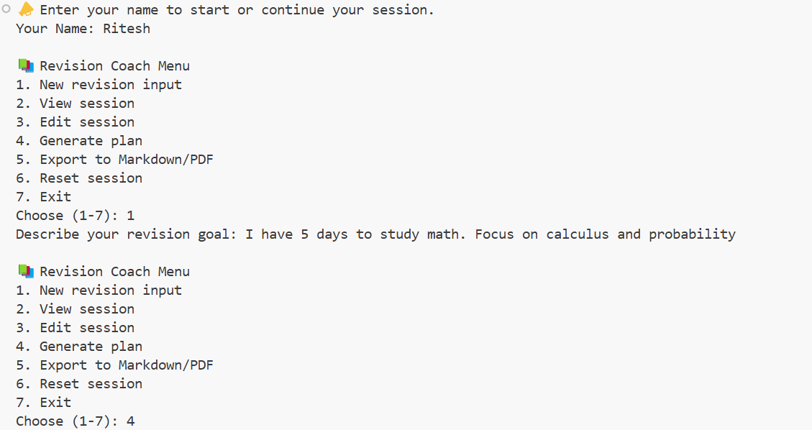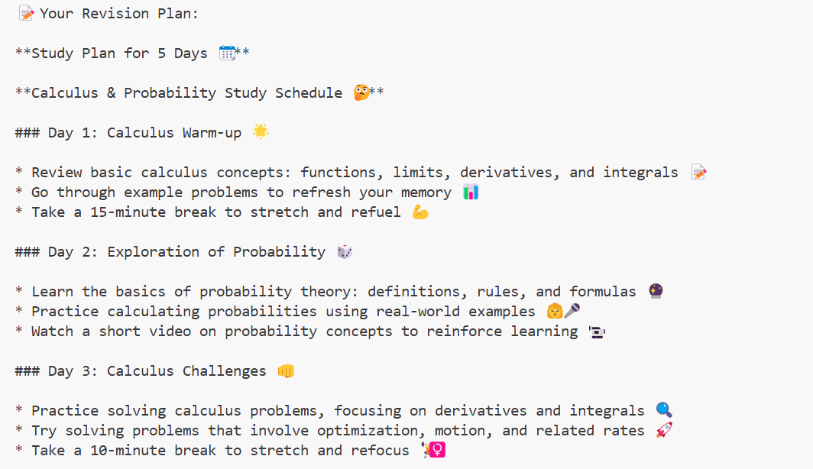

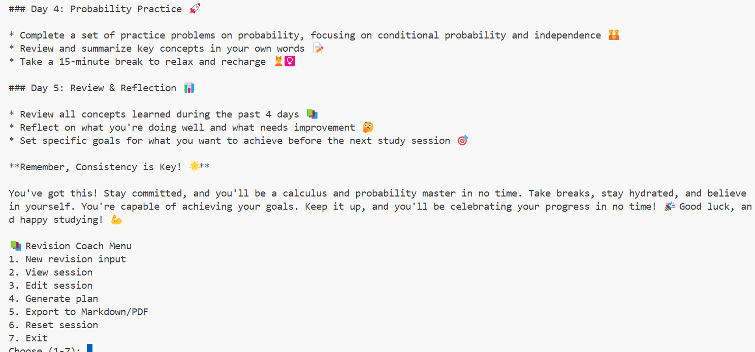

**Test 2: Vague Input**  
Input: "Help me revise science."  
Output:

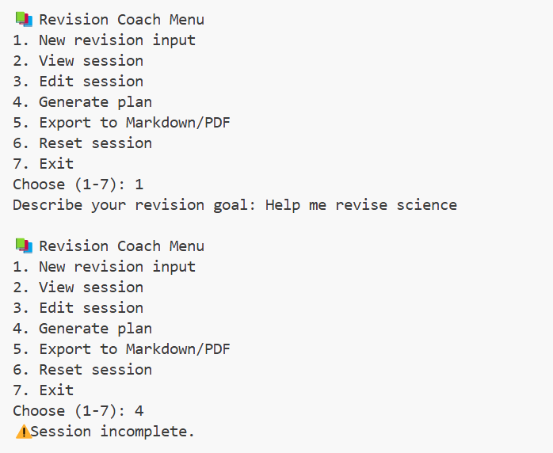

**Test 3: Empty Input**  
Input:   
Output:

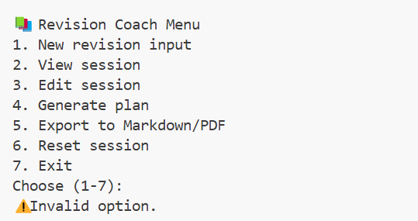

**🔄 SECTION 6: REFLECTION**

**6.1 What was the hardest part of this assignment?**  
The hardest part was dealing with API instability — first OpenAI’s model changes, then Groq model retirement. Each time, I had to refactor code, update prompts, and re-test flow. Ensuring the backend could consistently extract structured data from varied inputs while keeping session logic clean was also tricky.

**6.2 What part did you enjoy the most?**  
The most fun part was seeing the AI generate a helpful, supportive study plan with Markdown formatting, emojis, and motivational tone. Watching the system translate vague input into a personalized, well-structured plan felt like real magic — and made the whole experience feel alive..

**6.3 If given more time, what would you improve or add?**

* Add support for refining existing plans based on user feedback.
* Enable tracking progress across multiple subjects and sessions.
* Add reminders or schedule syncing.
* Build a minimal web or mobile UI to expand usability.

**6.4 What did you learn about ChatGPT or prompt design?**

I learned that prompt design is closer to system design than conversation — clear roles, strict formatting, and intentional phrasing matter a lot. I also learned how to debug LLM output, update API calls under pressure, and think like a pipeline: input → session state → model task → final output.

**6.5 Did you ever feel stuck? How did you handle it?**  
Yes — especially when models were decommissioned or API keys failed without clear messaging. I handled it by digging through docs, experimenting with fallbacks, and switching to Groq’s models. Breaking issues into smaller parts and testing iteratively helped me stay focused and find solutions faster.

**🧠 SECTION 7: HACK VALUE**

Did you go beyond the brief in any way?

Yes, I went beyond the brief in several ways:

* **Simulated multiple users** by building a profile-based session system where each user’s progress is saved and retrieved independently via a simple JSON store.
* **Added persistent memory** using file-based sessions so the assistant could remember each user’s subject, topics, and focus areas across runs.
* **Extended export logic** with both Markdown and PDF formats, which required integrating external tools like wkhtmltopdf and handling formatting dynamically.